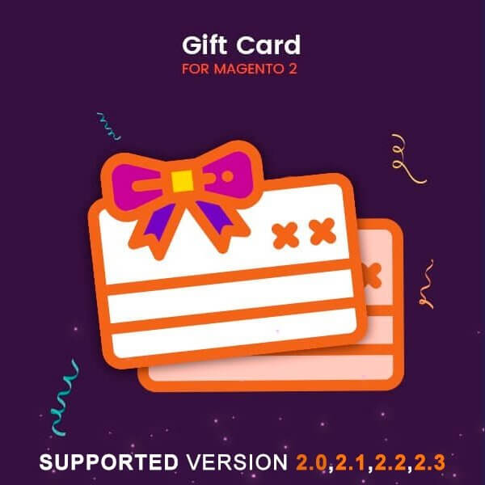

Gift card – Magento 2

USER MANUAL

Supported Version: 2.0, 2.1, 2.2, 2.3,2.4

Table Of Contents

Preface ......................................……………………………………......3

Installation...................................………………………………………..4

Option 1: Magento 2 install extension using COMMAND LINE .........…………..…..4
Option 2: Magento 2 install extension manually ………………………………….......5

Backend Example ………………………………………………………...……...6

Extension configuration………………………………………………………...6

Frontend Example………………………………………………………………….15

Preface:

Gift card is perfect extension for the store owners who wants to Add functionality of Gift product or Gift code in store. Once you enable this extension in your store as described follow it will apply Gift code in cart page Total price. When customer apply some gift code for the cart then first check the code if is valid and approve then apply discount on cart total price as per the configuration setting from backend.

Installation:

There are two ways of installing extension in magento2.

1) Using COMMAND LINE.
2) Manually install extension.

Option 1: Magento 2 install extension using COMMAND LINE (Recommended).

Follow below steps to install extension from the command line.

Step 1: Download the extension and unzip it.

Step 2: Upload it to code directory in your magento installation’s app directory.
If code directory does not exists then create.

Step 3: Disable the cache under System → Cache Management.

Step 4: Enter the following at the command line:
php bin/magento setup:upgrade
php bin/magento setup:static-content:deploy

Step 5: Once you complete above steps log out and log in back to the admin
panel and switch to Stores → Configuration → Mageants → Gift card.
The module will be displayed in the admin panel.

Option 2: Magento 2 install extension manually.

Step 1: Download the extension and unzip it.

Step 2: Upload it to code directory in your magento installation’s app directory.
If code directory does not exists then create.

Step 3: Disable the cache under System → Cache Management Edit
app/etc/config.php file and add one line code: ‘Mageants_Giftcard’ → 1

Step 4: Disable the cache under System → Cache Management

Step 5: Once you complete above steps log out and log in back to the
admin panel and switch to Stores → Configuration → Mageants →
Gift card, the module will be displayed in the admin panel.

Backend example

After Installation of Extension log in to magento admin panel for set configuration of the extension.
→ Main Menu
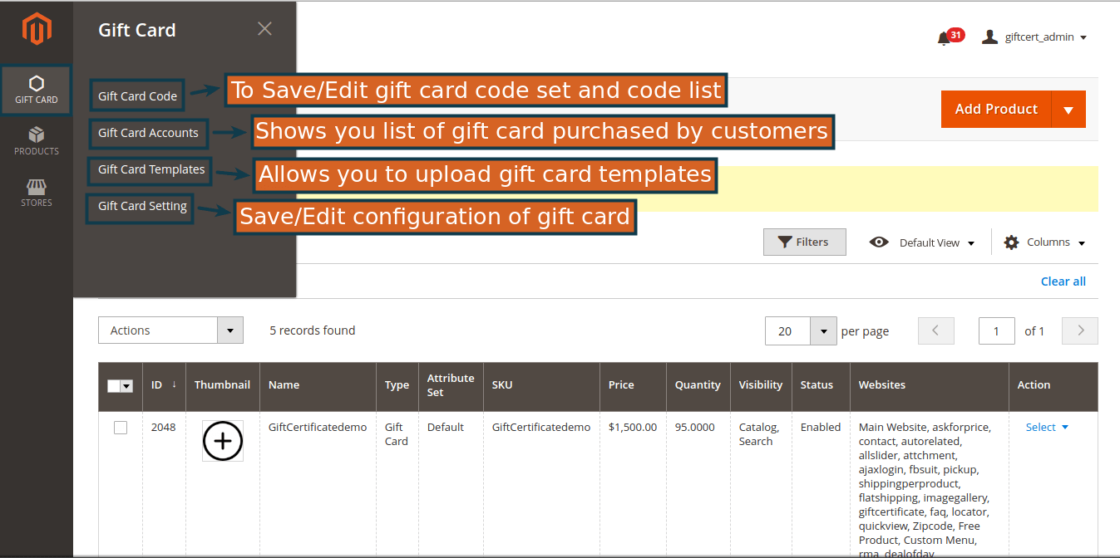
Extension configuration

→ Configuration

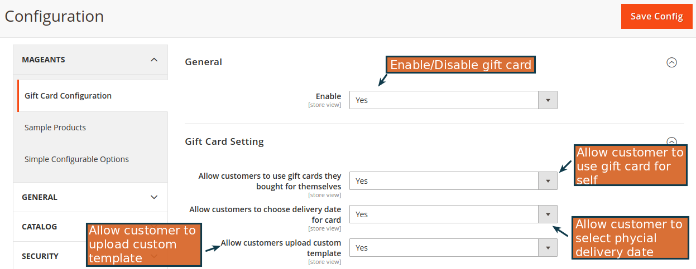

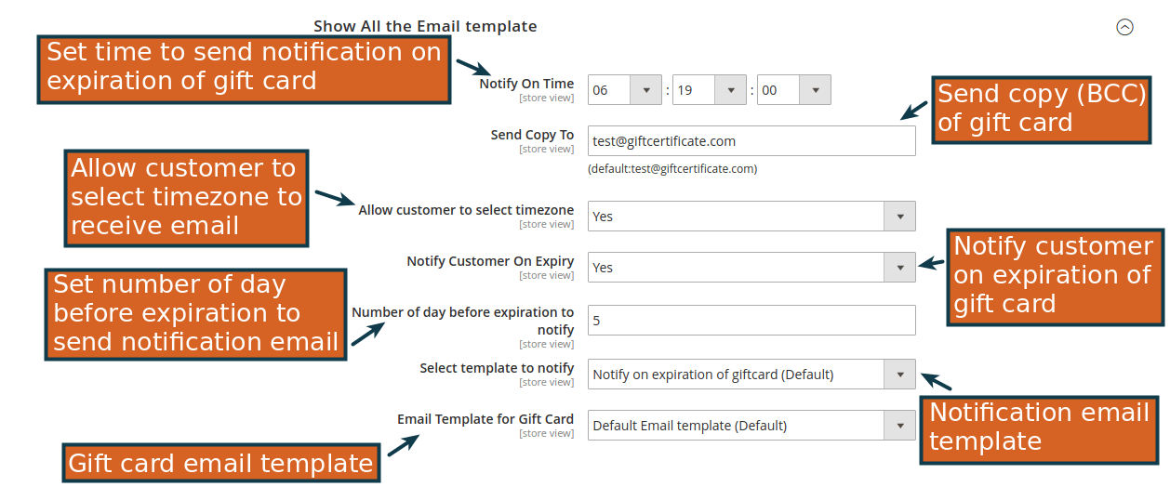

→ Add/Edit Codeset

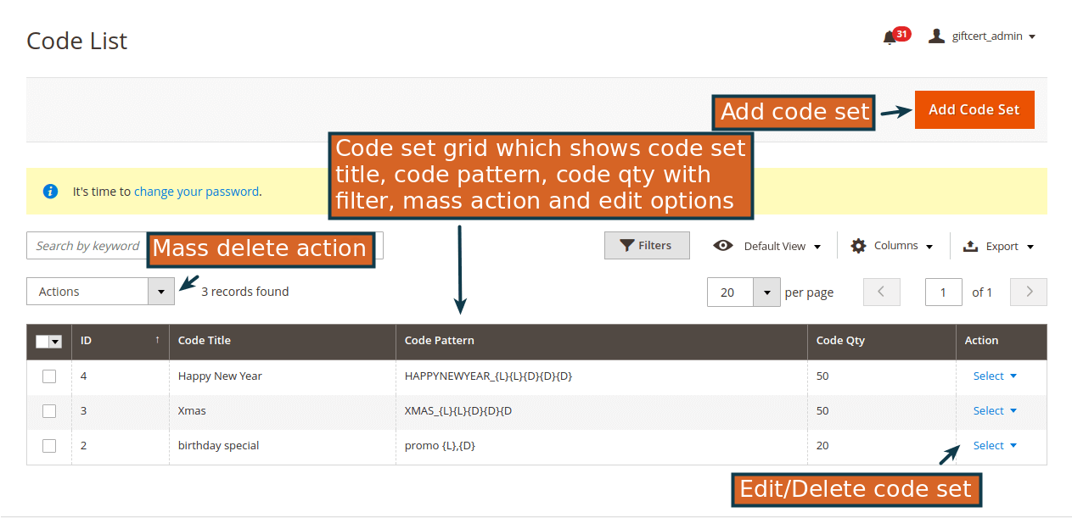

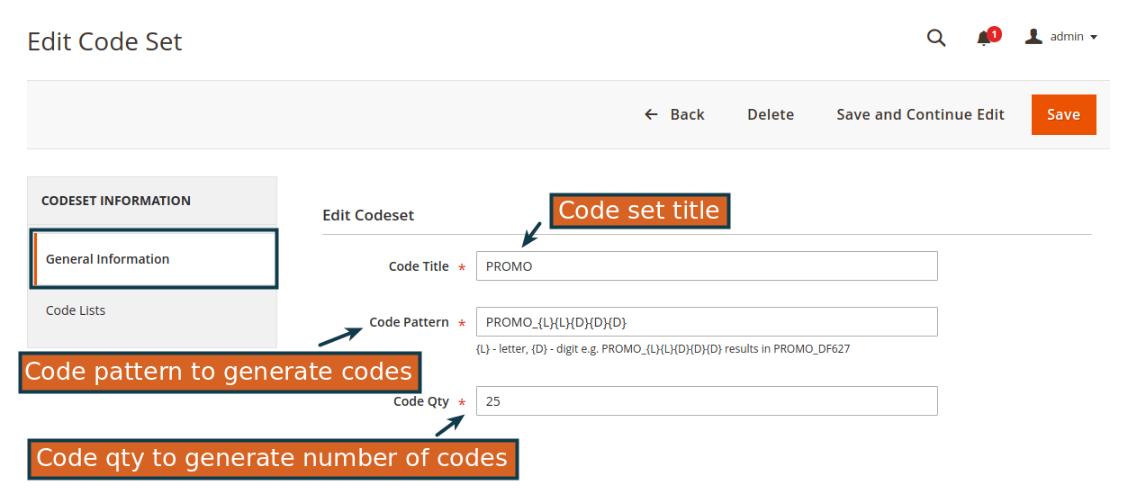

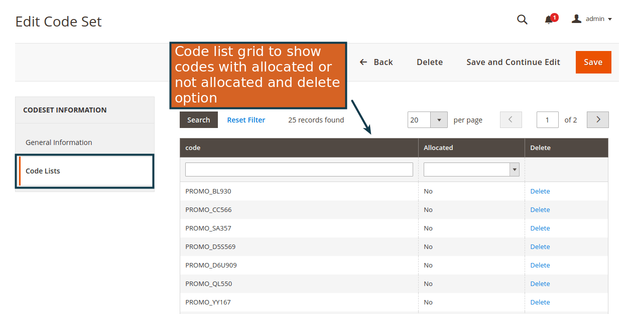

→ Gift Account
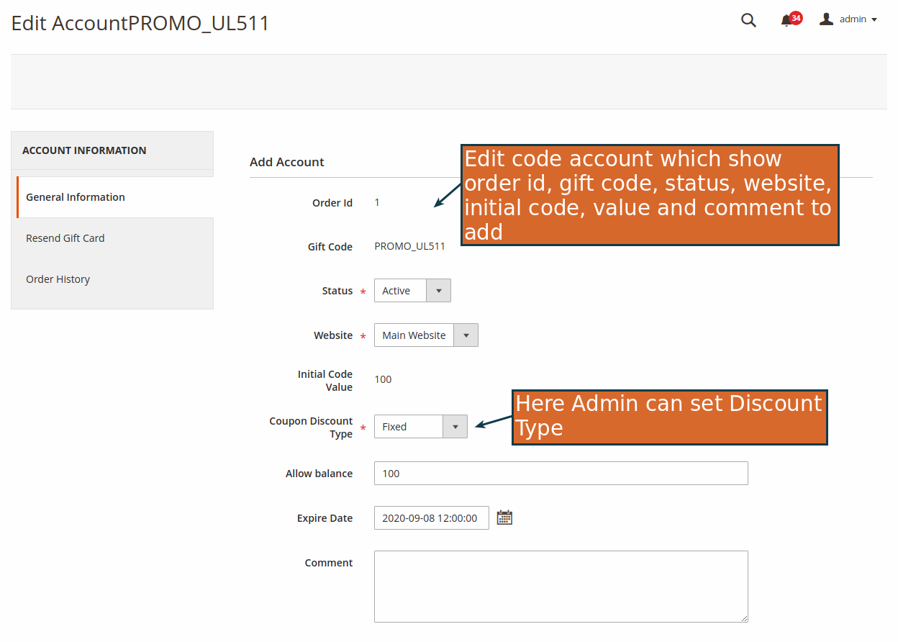

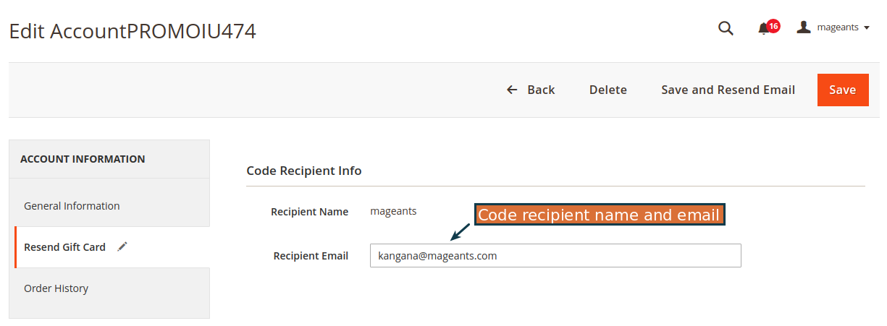

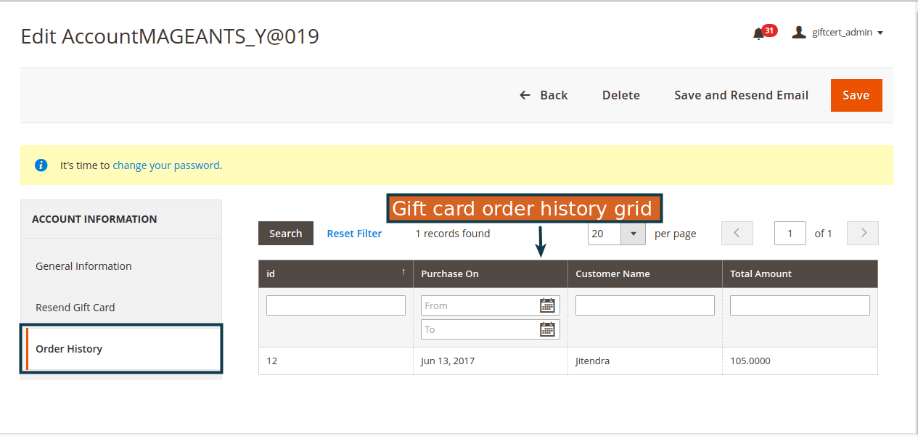

→ Gift Card Template

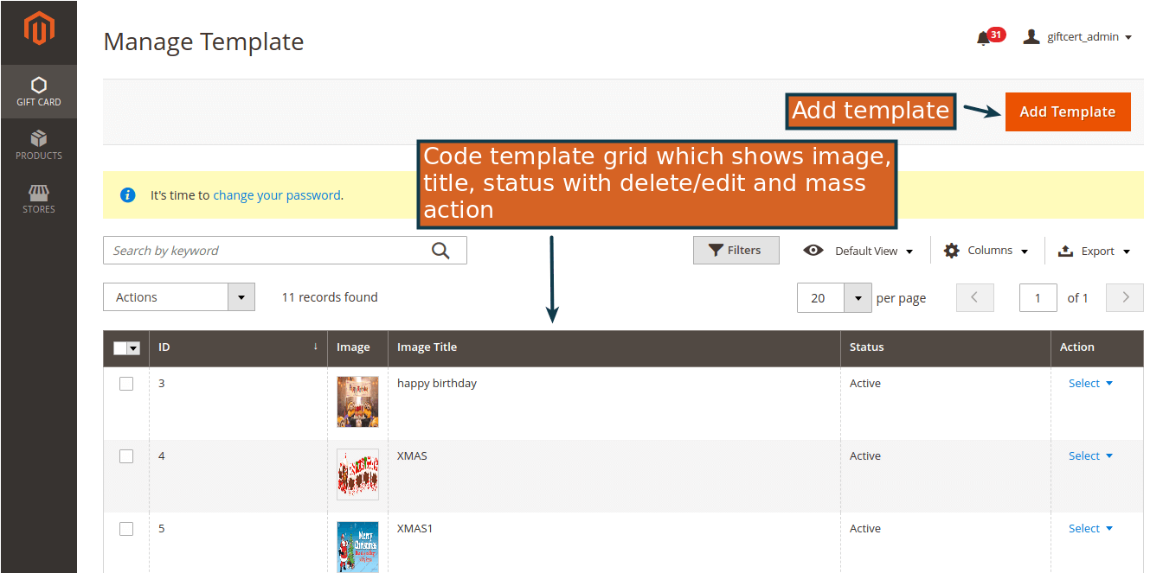

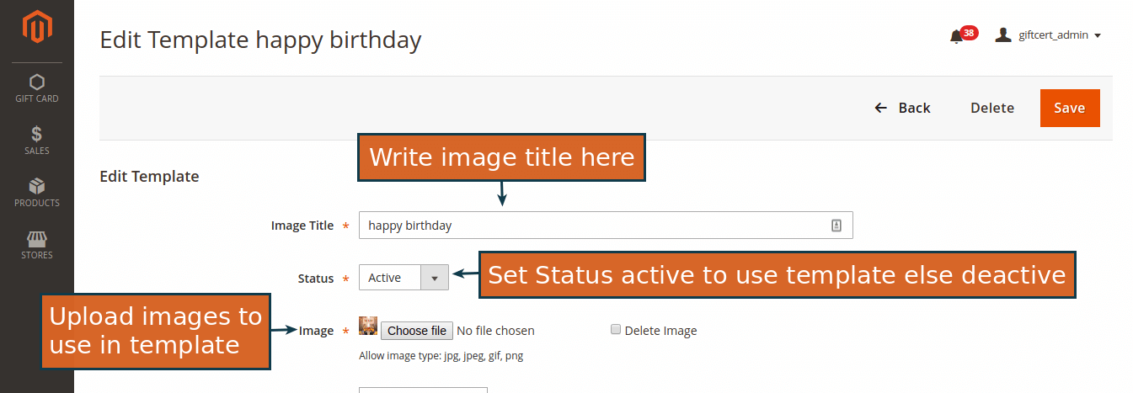
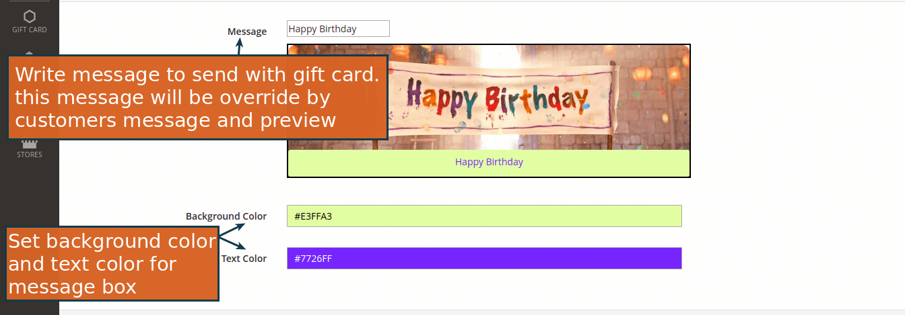

→ Gift Card Category
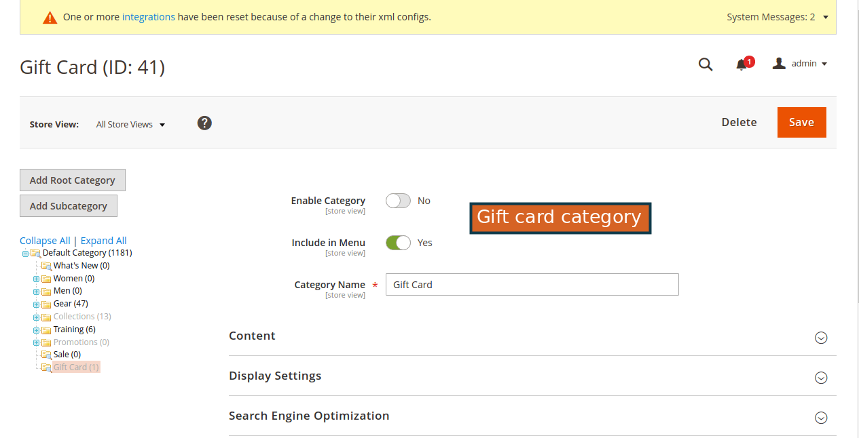

→ Create Gift Card Product
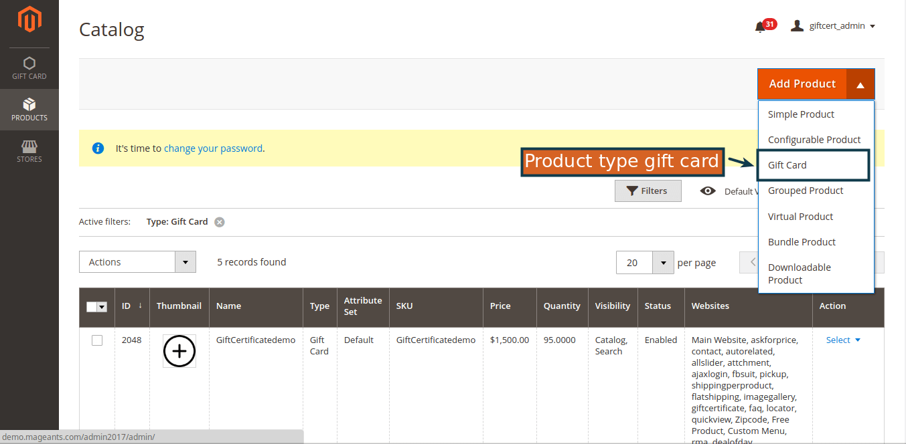

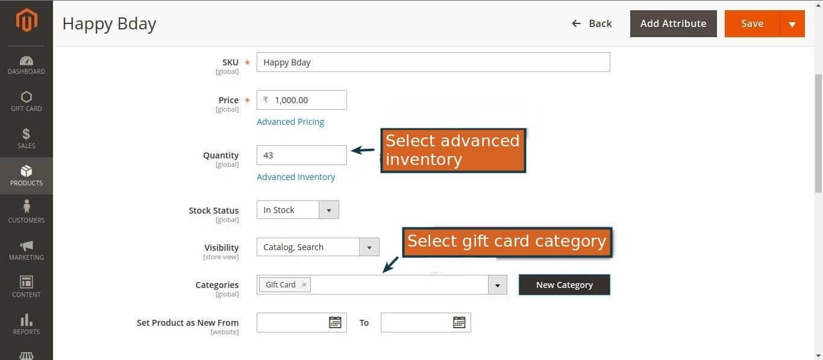

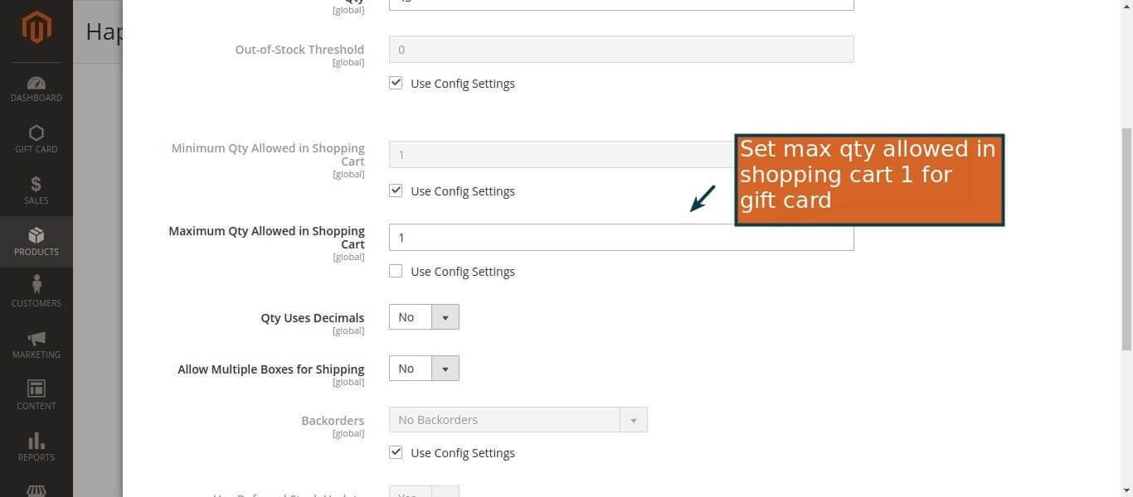

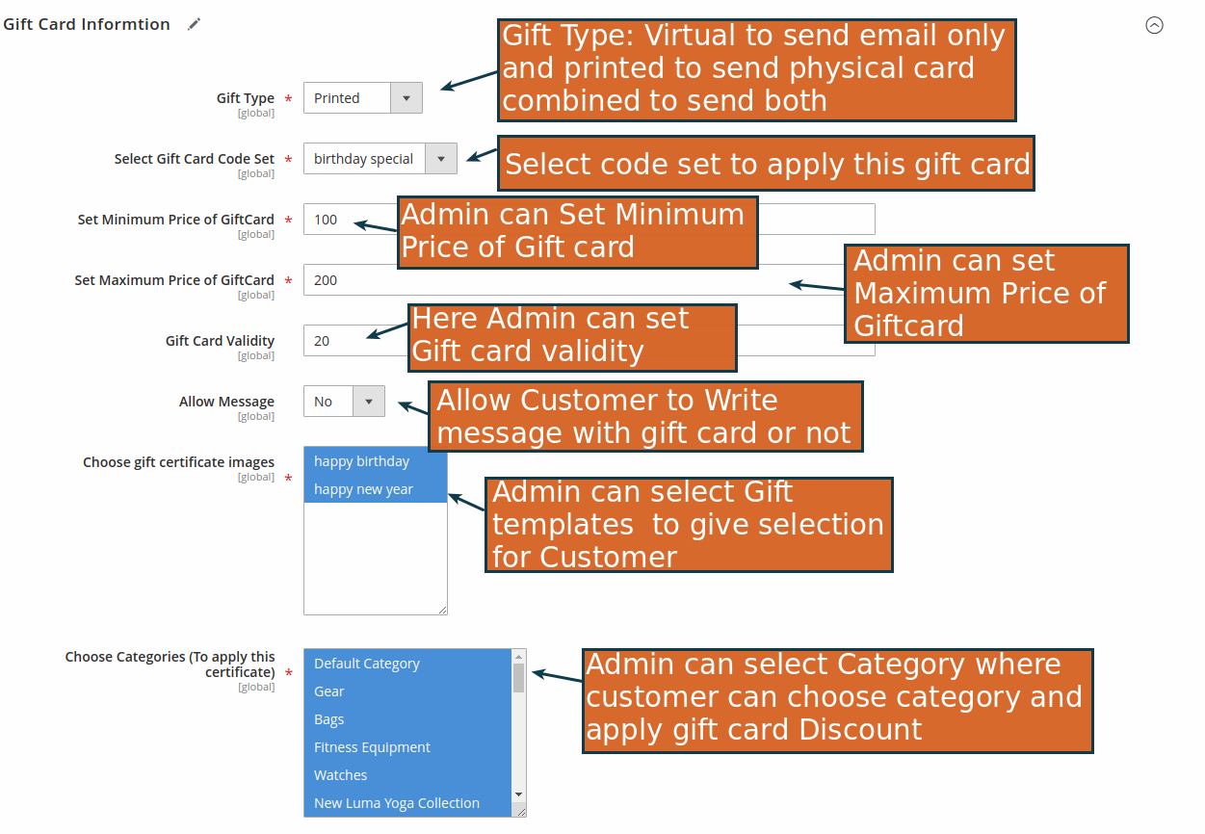

Frontend example
→ Gift Card Category
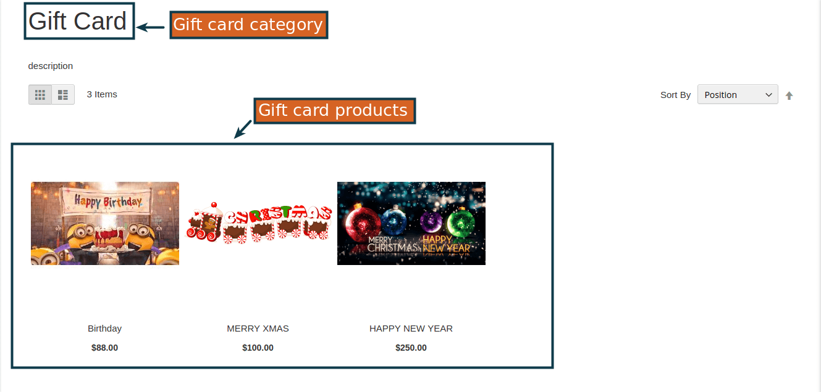

→ Gift Card Product View
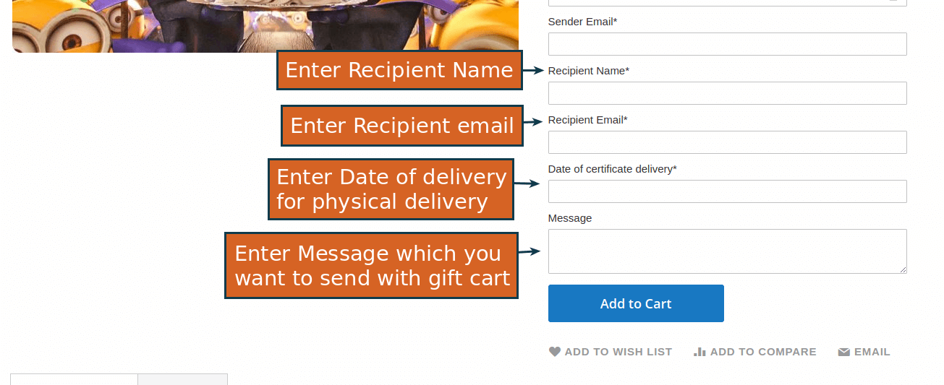

→ Gift Card Pop-Up
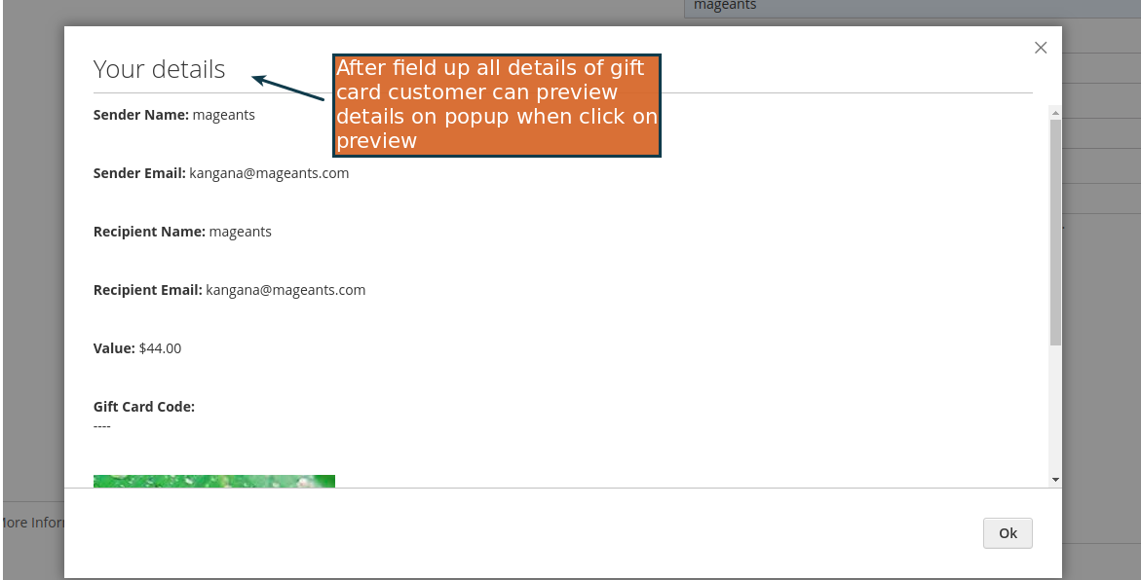
→ Cart Page (Added Gift Card)
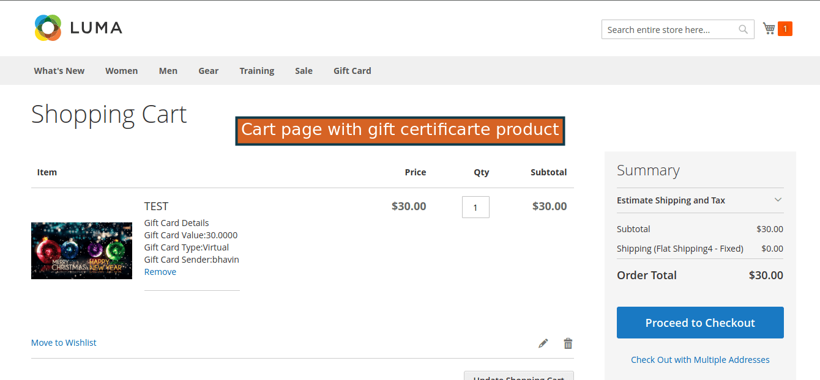

→ Place Order of Gift Card

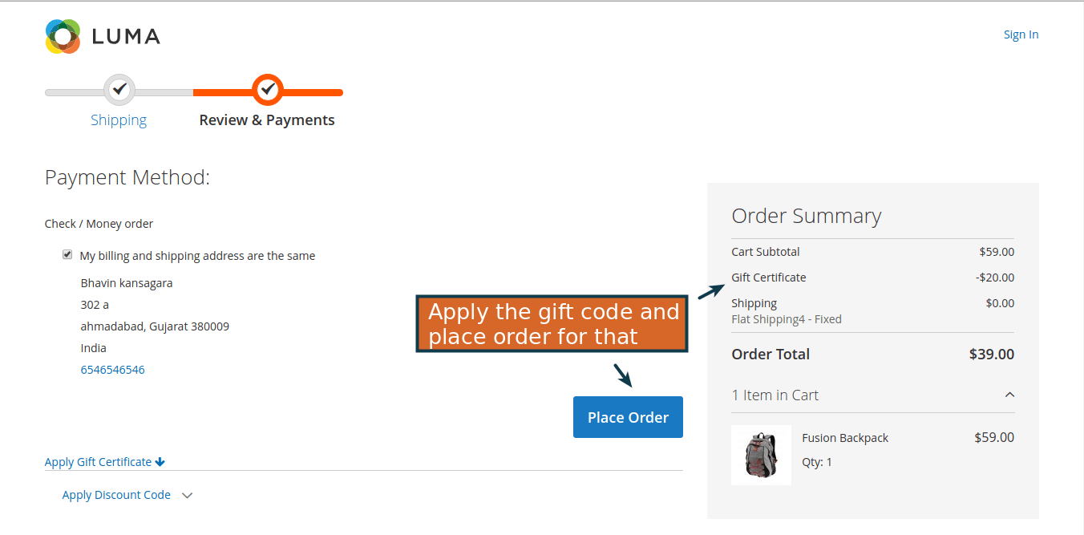

→ Cart to check and apply gift card
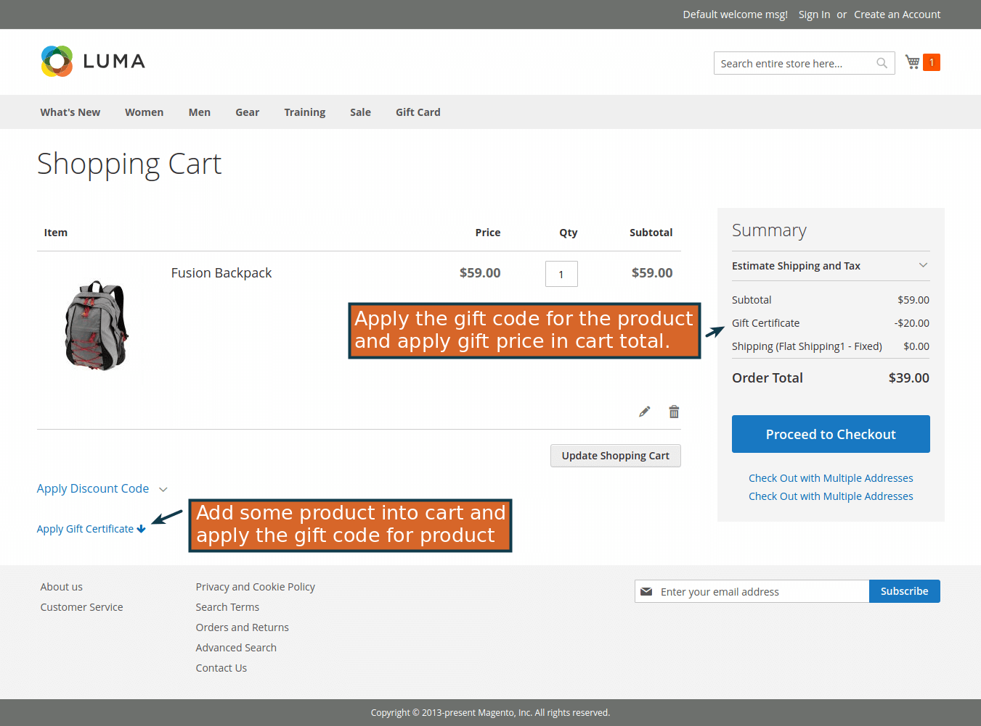
→ Checkout

→ My Account

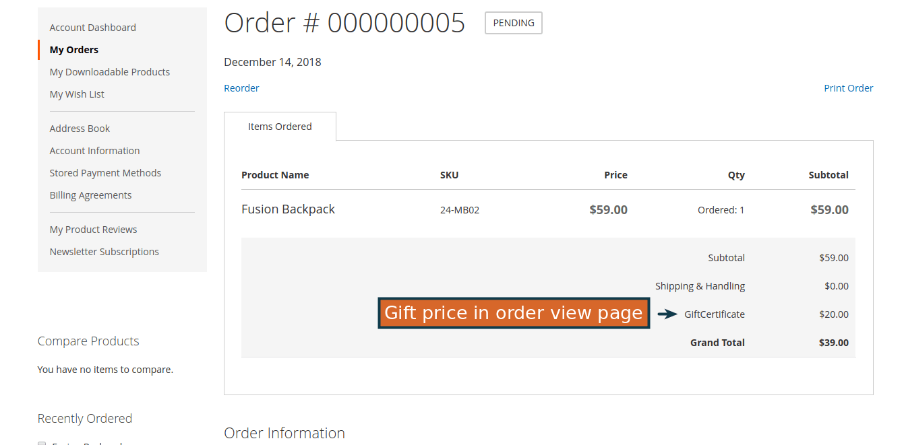
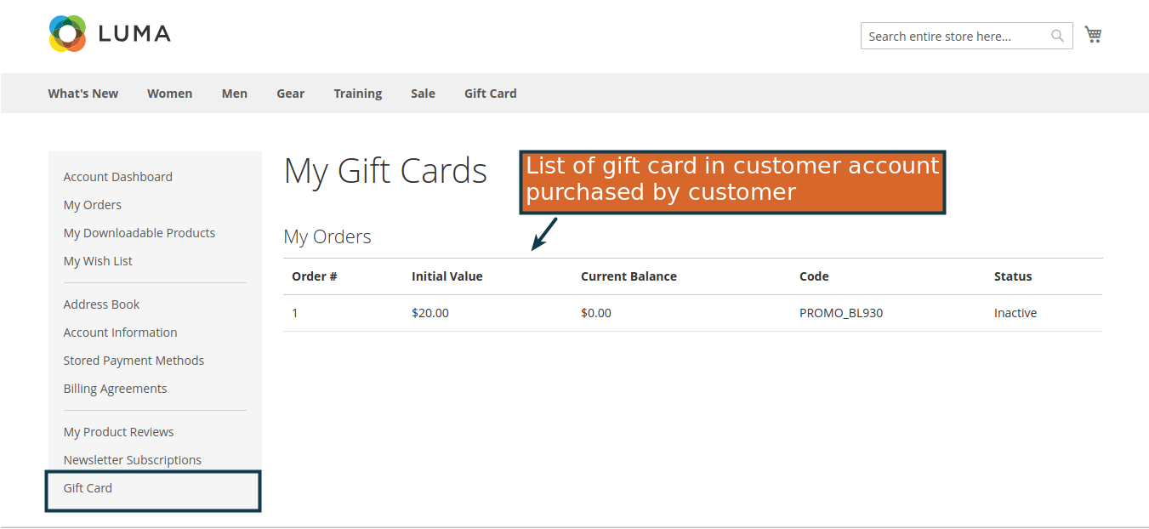

→ Admin Order View

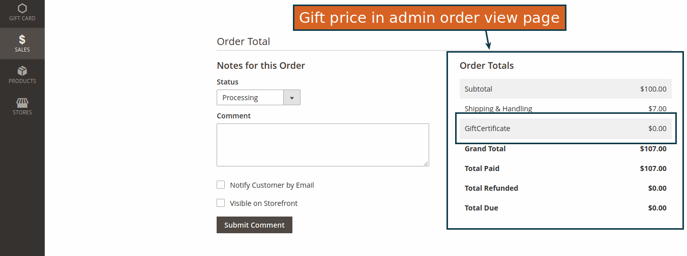

Thank you!
if you have any questions or feature suggestions, please contact us at: https://www.mageants.com/contact-us

Your feedback is absolutely welcome!

